12 maja 2020 klasa 5a

Temat: Odejmowanie liczb całkowitych.

Cele lekcji:
Uczeń:
- odejmuje liczby całkowite o tych samych i różnych znakach,
-wie co to są liczby całkowite.

Zad.2 str.216
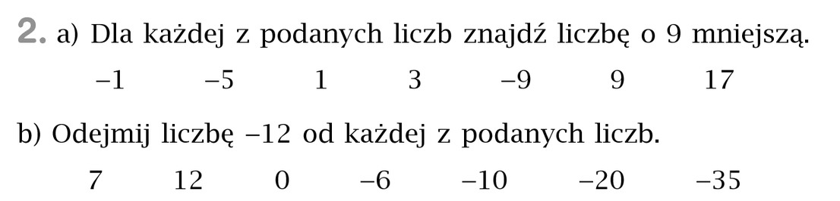
- -1-9 = -10 b) 7 – ( -12 ) = 7+12 = 19
-5-9 = -14 12 – (-12) = 12 + 12 = 24
1-9 = -8 0 – (-12) = 0 + 12 = 12
3-9 = -6 -6 – (-12) = - 6 + 12 = 6
-9-9 = -18 -10 – (-12) = - 10 + 12 = 2
9-9 = 0 - 20 – (-12) = - 2 0+ 12 = - 8
17-9 = 8 - 35– (-12) = - 35 + 12 = - 23

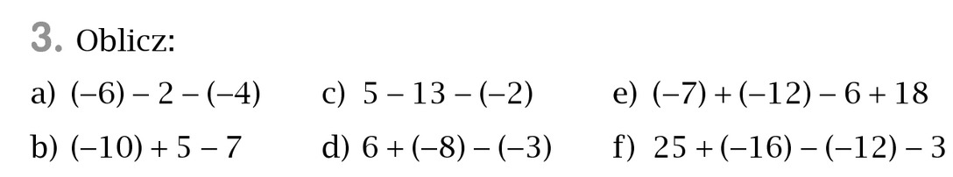
Zad.3 str.216

- (-6)-2- ( -4) = (-6) -2 + 4 = -8 + 4 = - 4
- (-10) + 5 – 7 = (-5) – 7 = - 12
- 5 – 13 – ( -2) = - 8 + 2 = - 6
- 6 + (-8) – (-3) = -2 + 3 = 1
- (-7) + (-12) – 6 + 18 = -19 – 6 + 18 = - 25 + 18 = - 7
- 25 + (-16) – (-12) – 3= 9 + 12 – 3 = 21- 3 = 18

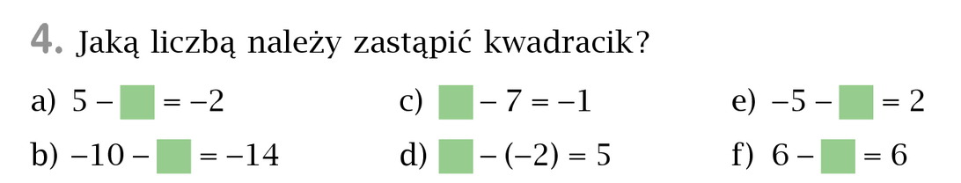
Zad.4 str.216

- 7
- 4
- 6
- 3
- – 7
- 0

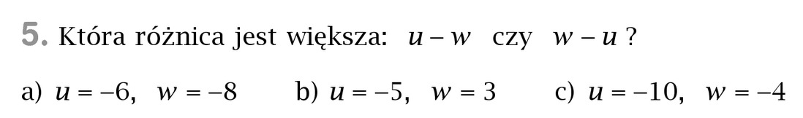
Zad.5 str.216

- u – w = -6 – (-8) = -6 + 8 = 2
w – u = -8 – (-6) = -8 + 6 = -2
u – w > w – u

- u – w = -5 – 3 = - 8
w – u = 3 – (-5) = 3 + 5 = 8
u – w < w – u

- u – w = -10 – (-4) = -10 + 4 = - 6
w – u = -4 – (-10) = -4 + 10 = 6
u – w < w – u

Proszę wykonać w zeszycie ćwiczeń zad. 3,4,5 str. 115, zad. 6,7 str. 116
Nie odsyłamy.

